
Project Title: AI Smart Helper — Case Study

Group Name: Brainy Bytes
Group Members:
Duduzile Mthethwa
Linda Hlazo
Lucy Shai
Thando Mngomezulu
Baxolile Dubazana

Table of Contents
1. Identify the Problem
1.1 What everyday home challenge is your AI helper solving?
1.2 Who in the family benefits most from it?
2. Describe Your AI Solution
2.1 What does your smart helper do?
2.2 What AI feature(s) does it use?
2.3 Is it a voice assistant, robot, app, or something else?
3. Show How It Works
3.1 Explain how a user interacts with it (talks to it, uses an app, etc.)
3.2 Include a simple flowchart or sketch showing usage (hand-drawn is fine).
4. Real-Life Examples
4.1 Mention 2 for existing smart home technologies (like Google Home, Alexa).
4.2 Say what they do and how your idea is similar or different.
5. Ethical Considerations
5.1 Are there any risks (e.g., privacy, over-reliance)?
5.2 How will you make your AI safe and respectful?

1. Identify the Problem
Many households face challenges in managing daily responsibilities such as completing chores, organizing grocery lists, tracking homework, maintaining routines, and remembering important tasks. These challenges often arise due to busy schedules, information overload, and lack of structured systems to manage tasks efficiently.
As a result, individuals and families encounter:
- Increase stress and anxiety.
- Missed deadlines and duties.
- Reduced productivity
- Poor time management.
- Conflict among households due to unfinished jobs
Research shows that a significant number of people miss doses due to:
- Forgetfulness
- Complex medication schedules
- Lack of reminders
- Busy daily routines
- Confusion about dosages
Who Benefits the Most?
1. Elderly People
2. People with Chronic Conditions
3. People Taking Daily Pills
4. People Using Contraceptive
5. Pregnant Individuals

2. Describe Your AI Solution
Name of AI Solution: HomeSmart AI Helper
HomeSmart AI Helper is a smart, AI-driven home assistant created to assist families in managing their everyday activities more effectively. It merges automation, customized reminders, and tailored suggestions to alleviate stress, enhance organization, and promote health and wellness.
What Does It Do?
1. Task & Chore Management: Families may better manage everyday household tasks like cleaning, laundry, and maintenance with the aid of HomeSmart AI. This guarantees that duties are delegated and that nothing is overlooked.
2. Grocery List & Shopping Management: The technology makes grocery shopping easier by assisting users in making wise grocery management decisions. This keeps you from running out of necessities and cuts down on pointless shopping trips.
3. Homework & Learning Support for Children: HomeSmart AI helps kids with their school tasks. This encourages improved time management and school success.
4. Family Schedule Management: AI consolidates all family events into a single platform. This enables families to remain orderly and prevent overlooked obligations.
5. Medication & Health Reminders: A system for observing health and managing medications, which is particularly beneficial for older adults and women’s well-being. This minimizes health hazards that can result from forgotten doses or inconsistent schedules.
6. Pregnancy & Wellness Support: The AI assists individuals throughout pregnancy and overall health. This helps future mothers to maintain their well-being more effectively.
7. Daily Routine Optimization: HomeSmart AI assists individuals in creating and upholding organized schedules. As time progresses, it develops a customized routine framework tailored to each person.
AI Features Used
Natural Language Processing (NLP) The system can understand and respond to human language.
Machine Learning—HomeSmart AI improves over time by learning user behavior.
Speech Recognition—The system allows hands-free interaction.
Smart Scheduling AI—This feature intelligently manages time and tasks.
Health Reminder System—This feature improves health compliance and safety.

Type of AI Tool
Mobile App: The mobile application serves as the main platform for everyday use, allowing users to receive notifications, set reminders, track tasks, and manage their household activities from anywhere.
Voice Assistant: The voice assistant enables hands-free interaction, making it ideal for elderly users and multitasking by allowing them to control the system and access information through simple spoken commands.
Smart Home Dashboard: The smart home dashboard acts as a central control system that displays schedules, tasks, and reminders while connecting seamlessly with smart home devices for efficient household management.
3. Show How It Works
User Interaction
- The HomeSmart AI is built to be user-friendly, whether you are technologically skilled or simply require hands-free assistance. Users can interact via:
- Voice commands involve talking directly to smart speakers or the mobile app (for example, "HomeSmart, add milk to the list").
- Mobile App Interface: Manually enter medication schedules, track pregnancy milestones, and review the family task board.
- Smart Dashboards: A central screen in the home (such as the kitchen) that shows the daily routines of all family members.
- Automated Alerts: When a medication or a scheduled task is due, the AI "pushes" notifications to your phone or announces them by voice.

Simple flowchart
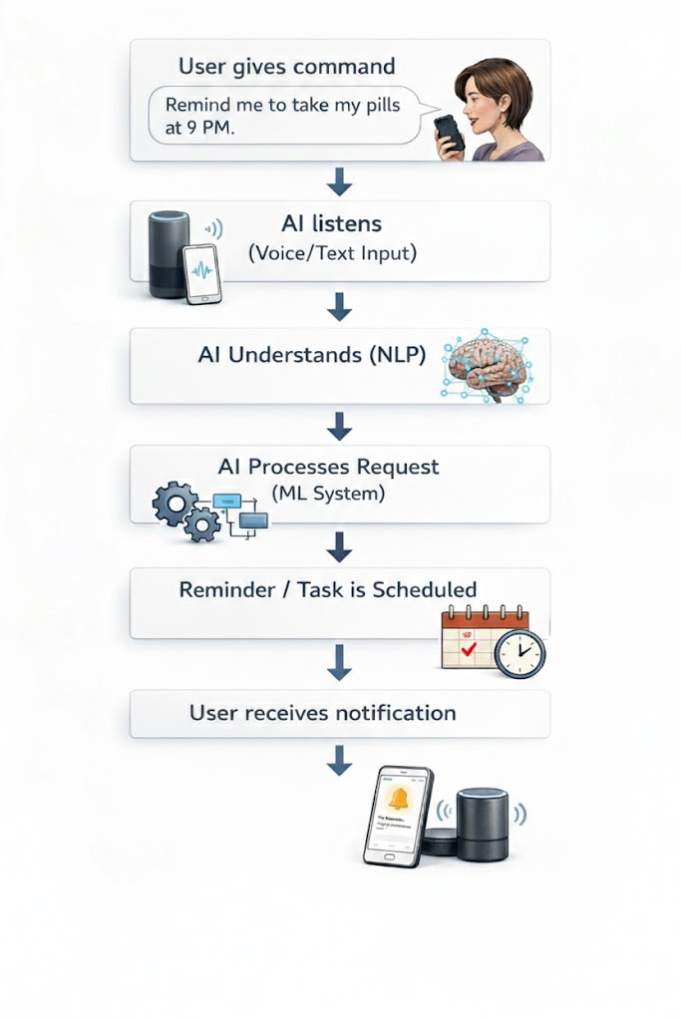

4. Real-Life Examples
Google Home
is a voice-activated smart assistant that manages your smart home from one platform. It controls lighting, heating, thermostats, and other devices remotely. It also sets reminders and alarms, answers questions, provides weather updates, streams music, podcasts, and news, and helps organize daily schedules. Additionally, it integrates apps and services to automate routines, schedule events, and delivers personalized information.
Similarities with HomeSmart AI:
- Both use voice commands for hand-free interaction.
- Both send reminders and notifications for tasks or events.
- Both assist in organizing daily routines, making life more efficient.
- Both can function as central smart assistants to manage multiple tasks in one place.
Distinctions from HomeSmart AI:
- Google Home focuses on general smart home control, entertainment, and convenience. HomeSmart AI focuses on family management, health monitoring, and personalized support.
- HomeSmart AI provides specialized reminders for medication, contraceptives, and prenatal supplements to prevent missed doses.
- It learns user habits and personalizes reminders and schedules for each family member, unlike the more general Google Home.
- HomeSmart AI combines task management (chores, homework) with wellness tracking and pregnancy care.
- It supports preventive health and organized family living beyond standard home automation.

2. Amazon Alexa
An AI-powered virtual assistant that helps users manage daily life tasks. It can create grocery and shopping lists, set reminders, alarms, and timers, answer questions, control compatible smart devices, and provide voice-based assistance for information, entertainment, and communication. Alexa also integrates with third-party apps and services, allowing users to automate routines and access various online services using voice commands.
Similarities with HomeSmart AI:
- Both use speech recognition and natural language processing to understand and respond to commands.
- Both assist in organizing tasks and schedules, sending timely alerts and reminders.
- Both provide a convenient, hands-free way to manage daily routines.
Distinctions from HomeSmart AI:
- Alexa is designed for general assistance, smart home management, and entertainment, rather than specializing in health tracking.
- HomeSmart AI focuses specifically on household organization and health supervision, helping families manage daily routines efficiently.
- HomeSmart AI provides personalized medication tracking, including reminders for seniors, contraceptive users, and pregnant individuals, ensuring adherence to health routines.
- HomeSmart AI offers a more family-centered approach, integrating health, chores, and scheduling in one system, whereas Alexa primarily serves as a general assistant.
- HomeSmart AI can learn household habits over time to suggest optimized routines, while Alexa focuses on task execution rather than predictive health or family management
5. Ethical Considerations
Possible Risks
- Handles personal health data, which can cause privacy concerns if not protected.
- Incorrect reminders, such as the wrong time or number of pills, could affect health.
- Users may over-rely on AI and stop checking prescriptions or doctors for advice.
- Children or the elderly may misuse or not fully understand the system.
- Over-dependence on technology could reduce responsibility and problem-solving.
How We Make It Safe and Respectful
- Store all health data securely and keep it private.
- Use real prescriptions to reduce mistakes.
- Users, parents, or caregivers can review and adjust reminders.
- AI communicates clearly, politely, and in simple language.
- Caregivers and parents can control settings for children and elderly users.
- Helps people but does not replace human decisions.
- Avoid bias and always communicate respectfully.
- Reminds users to check and confirm the correct dosage.
- Parents create medicine schedules, while children only get reminders.
- The AI uses respectful and inclusive language and supports multiple languages.

